Java 3 Activity 3 Task 4

30003389 – Kyer Potts

Table of Contents

Table of Contents i

Address how web applications are developed with different technologies, eg Java Technologies. E.g client side: JavaScript and server side: PHP, ASP.NET, Java 1

Demonstrate how to use a third party supplied package, e.g. JDBC connector.jar file in a NetBeans project 1

What is software development life cycle (SDLC) 2

# Address how web applications are developed with different technologies, eg Java Technologies. E.g client side: JavaScript and server side: PHP, ASP.NET, Java

Client side technologies such as Javascript, HTML and CSS are used to display information in a neat user friendly manner to an end user. They are also built with a small amount of processing functionality, and have implementations to send data to the back end for security and large scale processing purposes.

Server side technologies are built to receive data from the front end, and process that data within algorithms to generate an output to return to the Client facing side of the application.

# Demonstrate how to use a third party supplied package, e.g. JDBC connector.jar file in a NetBeans project

To connect to the database via a Java application, the JDBC plugin will need to be downloaded and added to the library files within the project. The JDBC connector can be found at <https://dev.mysql.com/downloads/connector/j/5.1.html>.

1. Once the connector has been downloaded, it can be added to the libraries folder of the project by right clicking on the folder and selecting the Add JAR option.
   1. 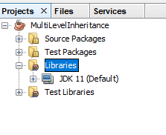
2. Once the connector has been added to the project it will show up in the libraries folder
   1. 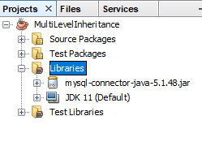
3. Once the JAR file has been added to the library, a connection string will need to be created within the program in order to connect to the database. Use the following code to connect to the database

String url = "jdbc:mysql://localhost:3306/movies_db"; //jdbc, database name and port

String user = "root"; //username

String password = "root"; //password

con = DriverManager.getConnection(url, user, password); // connection string

# What is software development life cycle (SDLC)

A software development life cycle (SDLC) is a planning tool used within software project management to map out and organise phases of project development. There are many different versions of SDLC’s, and these versions need to be chosen appropriately based on several factors including the size of the project, functional constraints, team size, cost, timeframe and deployment options. The most common SDLC’s are:

* The Waterfall Model
* The Agile Model
* The Iterative Model
* Rapid Application Development (RAD)